



ML Ops & Containerization
LAB MANUAL

Disclaimer: The content is curated from online/offline resources and used for educational purpose only
Creating and Managing a Local Git Repository - Weather Forecast Dashboard
Objective
To learn how Git tracks file modifications by creating, updating, staging, and committing changes in a Weather Forecast Dashboard project.
Problem Statement
A software developer is building a Weather Forecast Dashboard that displays the current weather of different cities. During development, new features and documentation are added regularly. The developer wants to use Git to track every modification and maintain different versions of the project.
Requirements
Software
- Git
- Visual Studio Code
- Command Prompt / Terminal
Procedure
Step 1: Create Project Folder
mkdir WeatherDashboard
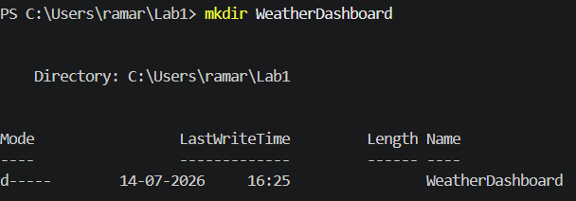
cd WeatherDashboard
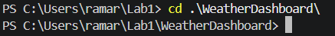
Step 2: Initialize Git Repository
git init
Step 3: Create README
# Weather Forecast Dashboard

## Project Description
The Weather Forecast Dashboard is a simple Python application that allows users to check the current weather information for a selected city.

## Features
- Enter city name
- Display weather details
- Show temperature
- Show humidity
- Show weather condition

## Technologies Used
- Python 3.x
- Git

## Project Structure

WeatherDashboard/
│
├── README.md
├── weather.py
└── .gitignore

## Author
Your name

Save as README.md
Step 4: Create weather.py
# Weather Forecast Dashboard

print("=" * 40)
print(" Weather Forecast Dashboard")
print("=" * 40)

city = input("Enter City Name: ")

# Sample weather data
temperature = 31
humidity = 72
condition = "Partly Cloudy"

print("\nWeather Report")
print("-" * 30)
print(f"City : {city}")
print(f"Temperature : {temperature} °C")
print(f"Humidity : {humidity}%")
print(f"Condition : {condition}")
print("-" * 30)

print("\nThank you for using the Weather Dashboard!")

Step 5: Check Status
git status
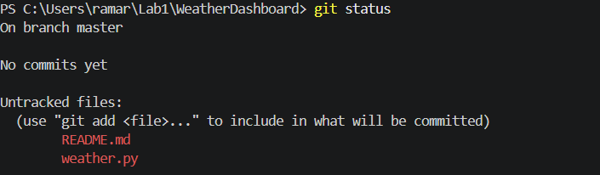
Step 6: Stage Files
git add .
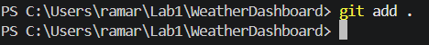

Step 7: Commit Files
git commit -m "Created Weather Dashboard project"
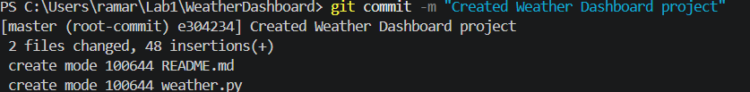
Step 8: Modify Python File
city = input("Enter City: ")
temperature = 32
print(f"{city}: {temperature}°C")
Step 9: View Modified Files
git status
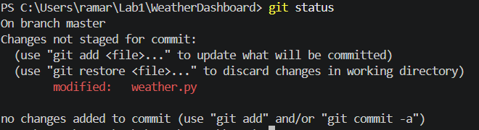
Step 10: View Differences
git diff
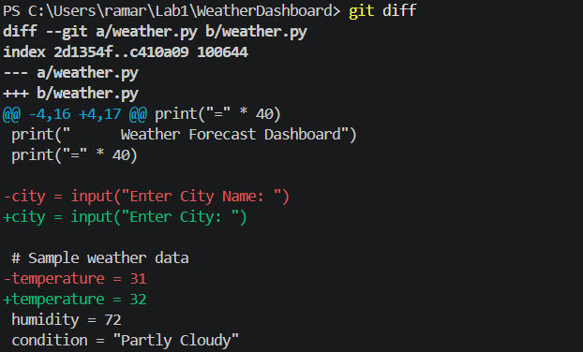
Step 11: Commit Updated Version
git add .
git commit -m "Added temperature display"
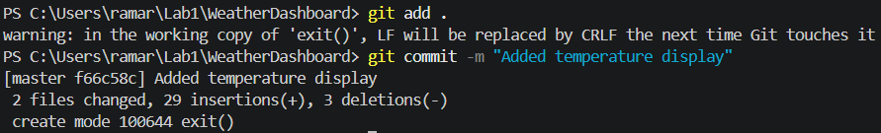
Step 12: View Commit History
git log --oneline
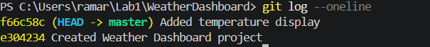
Conclusion
Students learned how Git tracks modified files, stages updates, commits new versions, and maintains a complete history of project changes.

